**Python Message Board Design Document**

**Description**

A message board application that features access tokens for security purposes.

This application will let the user to:

* Create Account
  + Name
  + Password
* Log In
  + Name
  + Password
* Send Message
  + Message text

**Data Structure**

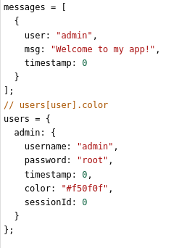

**Server endpoints/API**

**/**

**Type:** GET

**Description:**

Home page. User should be on this page at all times.

**Return:** index.html

**/get_messages**

**Type:** GET

**Description:**

Not a page. Server endpoint, return dictionary of messages.

**Return:**

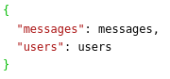

**/login**

**Type:** POST

**Description:**

Not a page. Server endpoint, given username, password, type of login (create account, login).

For login:

Must check if username exists and must check if password exists for the

username.

Write to data:



For create account:

Must check if username does NOT exist.

Write to data:

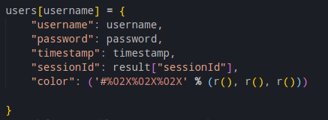

**Input (In an object/dictionary):**

“user”: Username of user

“pass”: Password of user

“time”: timestamp

“sessionId”: session id for the user

“type”: type of log in (“create”, “login”)

**Return:**

“create”: Given username and password, create account.

“exists”: When creating account, if account exists

“log”: Correct username and password

“incorrect”: Incorrect user name or password.

**/send_message**

**Type:** POST

**Description:**

Not a page. Server endpoint, given username, message, session id, timestamp.

Check session ids.

If session ids match for the user:

Write to data:

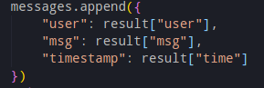

**Input (In an object/dictionary):**

“user”: Username of user

“msg”: Message sent

“time”: timestamp

“sessionId”: session id for the user

**Return:**

“message sent”: if session id == session id stored

“FAIL”: if session id != session id